# 1.MDE0154A152152BW

AFFICHEUR E-PAPER, 152X152 PIXELS, 1.54"

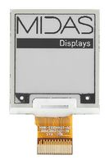

1.distributeur:

Farnell

2.type de connecteur:

Spi or i2c

3.fabriquant

Fabricant :

[MIDAS](https://fr.farnell.com/b/midas)

Réf. Fabricant:

MDE0154A152152BW

4.Prix:

10,37 €

5.Lien de doc:

<http://www.farnell.com/datasheets/2822931.pdf?_ga=2.32212666.524363685.1602234027-117065454.1602234027>

6.Détail produit:

MDE0154A152152BWis an Active Matrix Electrophoretic Display (AMEPD), with interface and a referencesystemdesign. The 1.5” active area contains 152×152 pixels, and has 1-bit B/W full display capabilities. Anintegratedcircuit contains gate buffer, source buffer, interface, timing control logic, oscillator, DC-DC.SRAM.LUT, VCOMandborder are supplied with each panel.

# 2.MDE029A128296BW

AFFICHEUR E-PAPER, 128 X 296 PIX, 2.9"

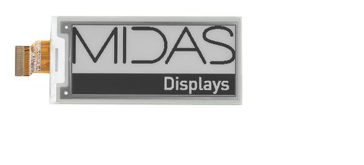

1.Distributeur:

Farnell

2.type de interface:

I2C or SPI

3.fabriquant

Fabricant :

[MIDAS](https://fr.farnell.com/b/midas)

Réf. Fabricant:

MDE029A128296BW

4.Prix:

16,81 €

5.Lien de doc:

<http://www.farnell.com/datasheets/2822933.pdf?_ga=2.251459407.837736134.1602369637-117065454.1602234027>

6.Détail produit:

MDE029A128296BW is an Active Matrix Electrophoretic Display(AMEPD) , with interface and a reference system design. The 2.9' active area contains 128×296 pixels, and has 1-bit full display capabilities. An integrated circuit contains gate buffer, source buffer, interface, timing control logic, oscillator, DC-DC. SRAM. LUT ,VCOM,and border are supplied with each panel.

# 3.EA W128128-XRLG

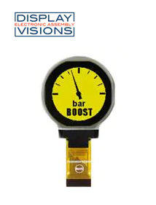

1.Distributeur:

Mouser

2.type de interface:

I2C or SPI

3.fabriquant

N° de fab. : EA W128128-XRLG

Fab. : [ELECTRONIC ASSEMBLY](https://www.mouser.fr/manufacturer/electronic-assembly/)

4.Prix:

38,46 €

5.Lien de doc:

<https://www.mouser.fr/datasheet/2/127/W128128-XR-1077981.pdf>

6.Détail produit:

Electronic Assembly 1.2" Round OLED Displays are low power, 37mm diameter, and 128x128 dot matrix displays. These LED displays are available in yellow, white, and blue display options. These displays feature a wide range of operating temperature from -40ºC to 80ºC. The 1.2" OLED displays are built to withstand harsh environments that might experience severe frost or tropical heat. These round OLED displays possess a fast response time (switching state time) of 10µs. The 1.2" round OLED displays feature 8-bit interface and SPI, I2C standards for serial communication. The blue and white variants (EA W128128-XRLB/W) offer 20,000Hrs lifespan while the yellow variant (EA W128128-XRLG) offers 50,000Hrs of lifespan. Typical applications include industrial and process automation markets for instrument gauges.

# 4.EA W064048-XALG

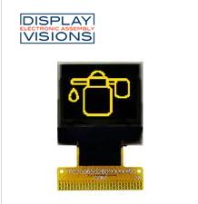

1.Distributeur:

Mouser

2.type de interface:

I2C or SPI

3.fabriquant

N° de fab. : EA W064048-XALG

Fab. : [ELECTRONIC ASSEMBLY](https://www.mouser.fr/manufacturer/electronic-assembly/)

4.Prix:

20,15 €

5.Lien de doc:

<https://www.mouser.fr/datasheet/2/127/W064048-XALG-1275539.pdf>

6.Détail produit:

ELECTRONIC ASSEMBLY OLED (Organic Light-Emitting Diode) Display Modules are low power dot matrix displays ideal for handheld applications. These LED displays are available in a variety of sizes and shapes, with a viewable diagonal range from 0.66" to 5.5", and in resolutions from 96 x 16 to 256 x 64. These OLED Display Modules require a low 3.3V operating voltage, feature an integrated controller, and a wide -40°C to +80°C operating temperature range. The EA OLED modules also feature a fast 10µs response time, even at -40°C. 8-bit parallel, I2C, and SPI interface options are available, and each includes a pre-installed flat flex cable for simple connection.

# 5.Connecteur FPC JST 24 Contacts pas 1.25mm, 2 Rangée(s), Femelle Angle droit, montage Traversant

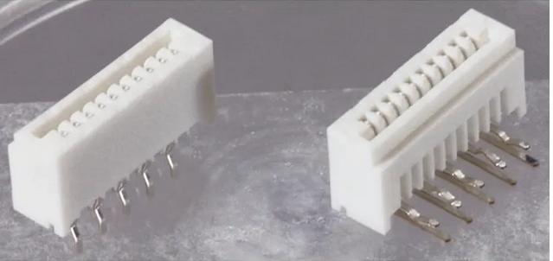

1.Distributeur:

RS Components SAS

2.type de interface:

I2C or SPI

3.fabriquant

Référence fabricant 24FE-ST-VK-N

4.Prix:

0,306 €

5.Lien de doc:

<https://docs.rs-online.com/fc9e/0900766b80c1ed0a.pdf>

6.Détail produit:

Connecteurs FFC de 1,25 mm, série FE de JST

Une gamme de connecteurs FFC (câble plat souple) au pas de 1,25 mm de JST. La série FE garantit une connexion par câble facile et sûr, avec une insertion aisée et des performances de contact fiables. Les connecteurs sont disponibles avec 4 à 40 contacts, en types droit (entrée verticale) et à angle droit (entrée latérale).

• Tension nominale : 100 V c.a./c.c.  
• Intensité nominale : 1 A  
• Résistance de contact initiale : < 20 mΩ  
• Faible force d'insertion et forte pression de contact  
• Connexions enclipsables  
• Homologation UL E60389  
• Certification CSA LR20812  
• Conforme à la directive RoHS

Connecteurs au pas de 1,25mm FFC