ESP8266-01S Modul Datenblatt

# Contents:

1. Description  
2. Specifications  
3. Pin Configuration  
4. Schematics Diagram  
5. Wiring Diagram  
6. Programming

1. Description

ESP-01 WiFi module is developed by Ai-thinker Team. Core processor ESP8266 in smaller sizes of the module encapsulates Tensilica L106 integrates ultra low power 32-bit bit MCU micro, with the 16 16-bit short mode. Clock  
speed support 80MHz, 160MHz, supports the RTOS, integrated Wi-Fi MAC/BB/RF/PA/LNA, /BB/RF/PA/LNA, on on-board antenna.

The module supports standard IEEE802.11 b/g/n agreement, complete TCP/IP protocol stack. Users can use the add modules to an existing device networking, or building a separate network controller.

ESP8266 is high integration wireless SOCs, designed for space and power. It provides unsurpassed ability to embed Wi-Fi capabilities within other systems,or to function as a standalone application, with the lowest cost, and minimal space requirement.

ESP8266EX offers a complete and self-contained Wi-Fi networking solution. It can be used to host the application or to offload Wi-Fi networking functions from another application processor.

When ESP8266EX hosts the application, it boots up directly from an external flash. In has integrated cache to improve the performance of the system in such applications.

Alternately, serving as a Wi-Fi adapter, wireless internet access can be added to any microcontroller based design with simple connectivity (SPI/SDIO or I2C/UART interface).

ESP8266EX is among the most integrated WiFi chip in the industry. It integrates the antenna switches, RF balun, power amplifier, low noise receive amplifier,filters, power management modules. It requires minimal external circuitry, and the entire solution, including front-end module. It is designed to occupy minimal PCB area.

ESP8266EX also integrates an enhanced version of Tensilica’s L106 Diamond series 32-bit processor, with on-chip SRAM, besides the Wi-Fi functionalities.

ESP8266EX is often integrated with external sensors and other application specific devices through its GPIOs. Codes for such applications are provided in  
the examples in the SDK.

Espressif Systems’ Smart Connectivity Platform (ESCP) demonstrates sophisticated system level features include fast sleep/wake context switching for energy-efficient VoIP, adaptive radio biasing, for low-power operation,  
advanced signal processing, and spur cancellation and radio co-existence features for common cellular,Bluetooth, DDR, LVDS, LCD interference mitigation.

1. Specifications

» 802.11 b/g/n  
» Integrated low power 32-bit MCU  
» Integrated 10-bit ADC  
» Integrated TCP/IP protocol stack  
» Integrated TR switch, balun, LNA, power amplifier and matching network  
» Integrated PLL, regulators, and power management units  
» Supports antenna diversity  
» Wi-Fi 2.4 GHz, support WPA/WPA2  
» Support STA/AP/STA+AP operation modes  
» Support Smart Link Function for both Android and iOS devices  
» Support Smart Link Function for both Android and iOS devices  
» SDIO 2.0, (H) SPI, UART, I2C, I2S, IRDA, PWM, GPIO  
» STBC, 1x1 MIMO, 2x1 MIMO  
» A-MPDU & A-MSDU aggregation and 0.4s guard interval  
» Deep sleep power <10uA, Power down leakage current < 5uA  
» Wake up and transmit packets in <2ms  
» Standby power consumption of <1.0mW (DTIM3)  
» +20dBm output power in 802.11b mode  
» Operating temperature range -40°C ~ 125°C

# 3. Pin Configuration

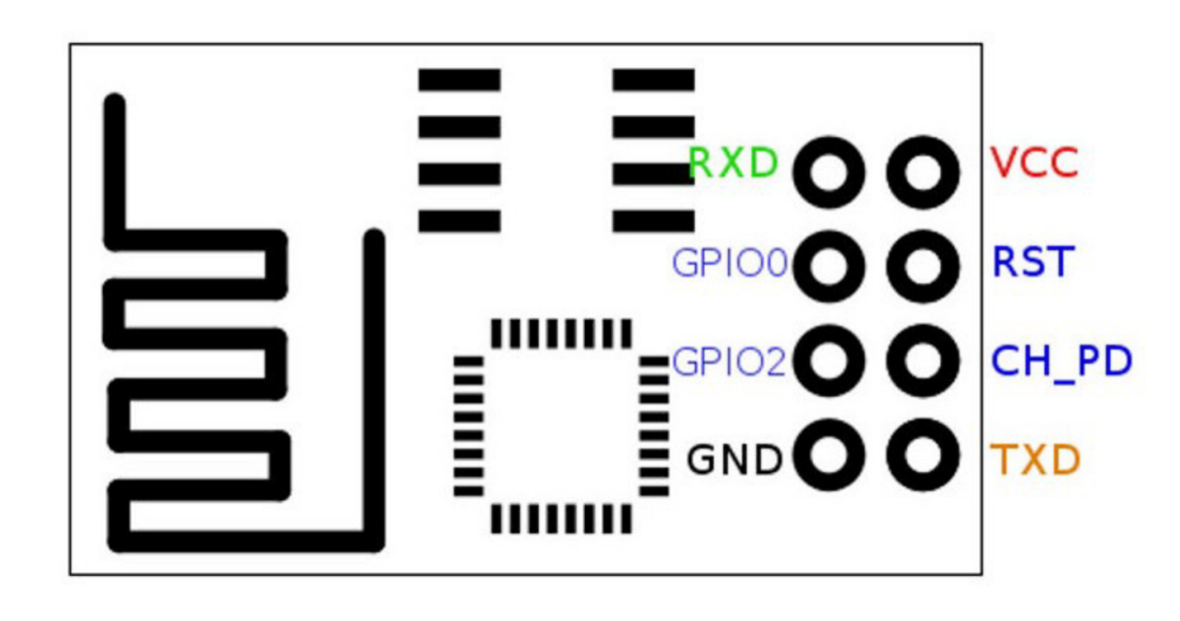

VCC +3.3V power supply  
GND Ground (0V)  
GPIO0 General Purpose Input/Output pin 0  
GPIO2 General Purpose Input/Output pin 2  
CH_PD Chip Enable  
RST Reset  
RX Receive line of Serial Interface  
TX Transmit line of Serial Interface

# 4. Schematics Diagram

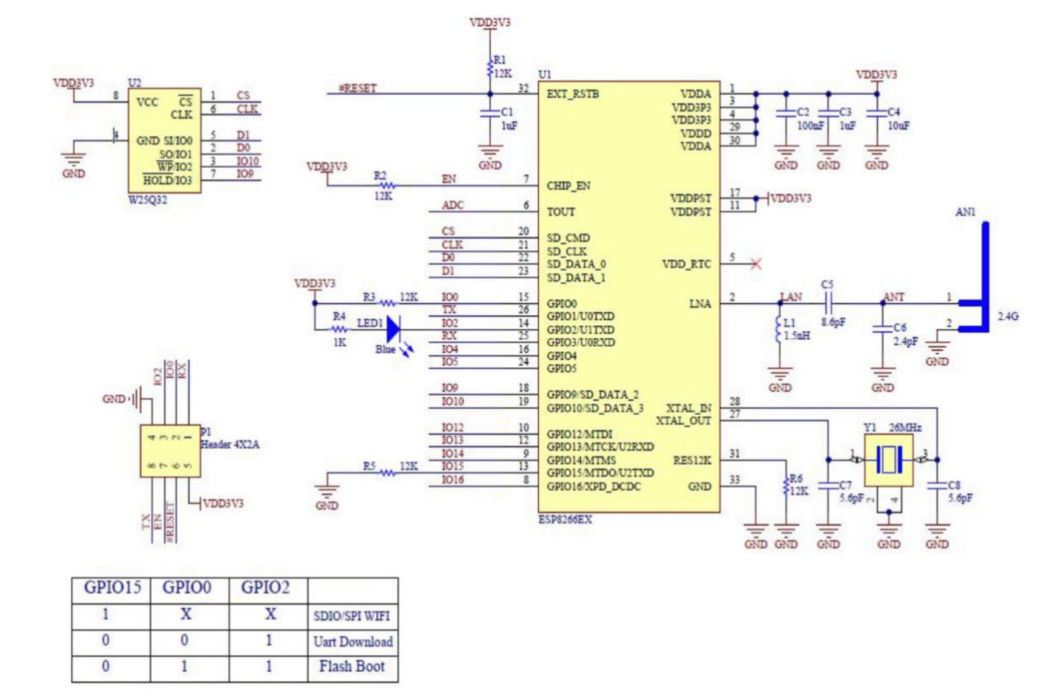

# 5. Wiring Diagram

Just make sure that both FTDI adapter and MB102 power supply run on+3.3V, NOT +5V. If any of them runs on +5V IT WILL DESTROY ESP-01S!!!

# 6. Programming

There are different ways to program the ESP8266, for example a method using the Arduino IDE. This is really easy for beginners, and it's a very familiar environment if you've used Arduino boards before.

Just keep in mind that you are not limited to this option. There is also an official SDK available to program it in real C, this is very useful if you want to optimize your code or do some advanced tricks that aren't supported by the Arduino IDE.

Another possibility is to flash it with a LUA interpreter, so you can upload and run LUA scripts. Or maybe you're more familiar with Python? Then you should check out the MicroPython firmware to interpret MicroPython scripts.

And many others.